

International School

**Capstone Project 1**

CMU-CS450

**Product Backlog – User Story – Sprint Backlog**

**Craft Village Pollution Monitor System**

**Submitted by**

**Ca, Van Cong Le**

**Huy, Bui Duc**

**Phuc, Hua Hoang**

**Trung, Nguyen Thanh**

**Approved by**

**Ph.D. Nguyen Thanh Binh**

**Proposal Review Panel Representative:**

Name Signature Date

**Capstone Project 1 - Mentor:**

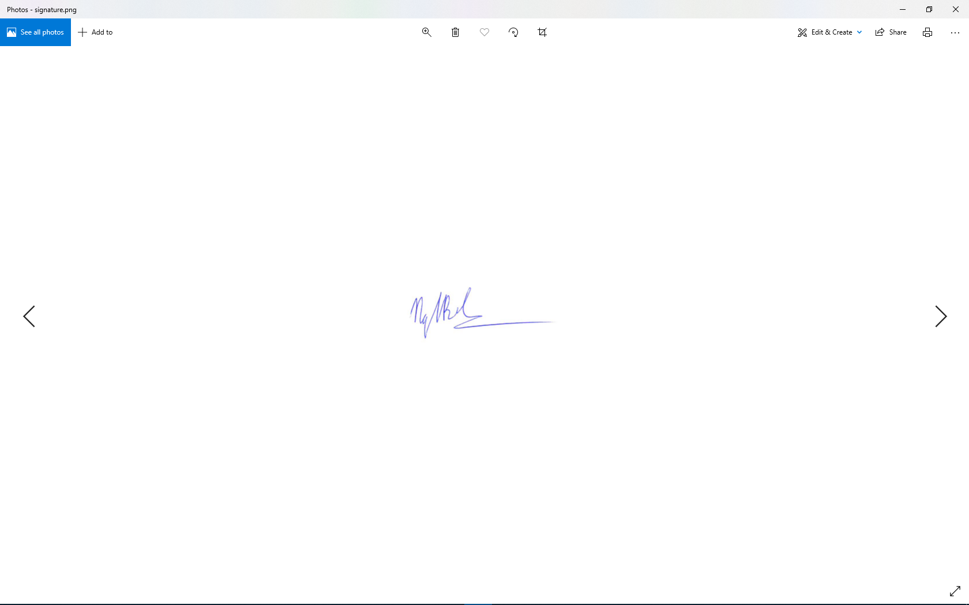

Name Signature Date

**PROJECT INFORMATION**

|  |  |  |  |
| --- | --- | --- | --- |
| **Project acronym** | CVPMS | | |
| **Project Title** | Craft Village Pollution Monitor System | | |
| **Start Date** | 22/08/2022 | **End Date** | 07/12/2022 |
| **Lead Institution** | International School, Duy Tan University | | |
| **Project Mentor** | Ph.D. Thanh Binh, Nguyen | | |
| **Scrum master / Project Leader & contact details** | Ca, Van Cong Le  *Email:* cascabusiness@gmail.com  *Tel:* 0352707895 | | |
| **Partner Organization** |  | | |
| **Project Web URL** | [*https://github.com/Casca113s2/craft-village-pollution-monitor-system*](https://github.com/Casca113s2/craft-village-pollution-monitor-system) | | |
| **Team members** | **Name** | **Email** | **Tel** |
| 25211207666 | Ca, Van Cong Le | [cascabusiness@gmail.com](http://cascabusiness@gmail.com) | 0352707895 |
| 25211215894 | Huy, Bui Duc | [duchuyltt122@gmail.com](http://duchuyltt122@gmail.com) | 0818648090 |
| 25211204084 | Phuc, Hua Hoang | [phuchuho0402@gmail.com](http://phuchuho0402@gmail.com) | 0905639682 |
| 25211215133 | Trung, Nguyen Thanh | [nguyenttrung2601@gmail.com](http://nguyenttrung2601@gmail.com) | 0774496838 |

**Approve Document:** Sign in to approve the document

|  |  |  |  |
| --- | --- | --- | --- |
| **Mentor** | Binh, Nguyen Thanh | Date | 08/11/2022 |
| Sign |  |
| **Scrum Master** | Ca, Van Cong Le | Date | 08/11/2022 |
| Sign |  |
| **Scrum Member** | Huy, Bui Duc | Date | 08/11/2022 |
| Sign |  |
| **Scrum Member** | Phuc, Hua Hoang | Date | 08/11/2022 |
| Sign |  |
| **Scrum Member** | Trung, Nguyen Thanh | Date | 08/11/2022 |
| Sign |  |

Table Of Contents

1. Product Backlog 6

2. Sprint Backlog 11

2.1. Sprint Plan 11

2.2. Sprint 1 12

2.3. Sprint 2 15

2.4. Sprint 3 19

2.5. Sprint 4 22

2.6. Sprint 5 25

3. Impediments 28

4. Retrospective 29

**Table Of Figures**

**Figure 1.** Sprint 1 Burn Down Chart 13

**Figure 2.** Sprint 1 Burn Up Chart 14

**Figure 3.** Sprint 2 Burn Down Chart 17

**Figure 4.** Sprint 2 Burn Up Chart 18

**Figure 5.** Sprint 3 Burn Down Chart 20

**Figure 6.** Sprint 3 Burn Up Chart 21

**Figure 7.** Sprint 4 Burn Down Chart 23

**Figure 8.** Sprint 4 Burn Up Chart 24

**Figure 9.** Sprint 5 Burn Down Chart 26

**Figure 10.** Sprint 5 Burn Up Chart 27

**Table Of Tables**

**Table 1.** Product Backlog 6

**Table 2.** Sprint Plan 11

**Table 3.** Sprint 1 12

**Table 4.** Sprint 2 15

**Table 5.** Sprint 3 19

**Table 6.** Sprint 4 22

**Table 7.** Sprint 5 25

**Table 8.** Impediments 28

**Table 9.** Retrospective 29

# Product Backlog

**Table 1.** Product Backlog

|  |  |  |  |  |  |  |  |  |  |  |  |
| --- | --- | --- | --- | --- | --- | --- | --- | --- | --- | --- | --- |
| **Id** | **Heading** | **As a …** | **I want to ...** | **so that ...** | **Acceptance Criteria** | **Remarks** | **Priority** | **Sprint No** | **Estimate (Hours)** | **Status** | **Remarks** |
| PB01 | Register | Personal User Household | Create an account | I can login with my own account to access the mobile application/web application | - Username must not contain spaces and not be accented  - Password must be >= 6 characters |  | 3 | 1, 2, 3 | 30 | Done |  |
| PB02 | Authenticate | Personal User Household Authority Admin | Login/Logout to mobile application/web application | I can start to conduct a new survey/provide the information about the craft village | - Login with registed account |  | 3 | 2, 5 | 100 | Done |  |
| PB03 | Authorize | Personal User Household Authority Admin | Login/Logout according to the role that has been registed | I can perform the task correctly according to the role | - Login with registed account and perform task according to the registed role |  | 3 | 2 | 100 | Done |  |
| PB04 | Password Recovery | Personal User | Recover password when forgot | I can change my password into the new one and get my account back | - Use the code that sent to the account's email which is registered in the profile to change the new password |  | 2 | 2 | 20 | Done |  |
| PB05 | Edit Profile | Personal User Household Local authority Admin | Edit my profile | I can edit my personal information | - Allow users to edit any personal information they want |  | 2 | 2 | 20 | Done |  |
| PB06 | Create Local Authority Account | Admin | Create an local authority account | I can provide the account to the local authority user to manage their local craft village | - Allow the admin to create the a local authority account  - Login with registed account |  |  | 3 | 30 | Done |  |
| PB07 | Change Password | Personal User Household Authority Admin | Change my old password into a new password | Next time I can login using my new password and protect my account in case of password leak | - Allow user to click "Thay đổi mật khẩu" and change their current password to a new password |  | 3 | 2 | 30 | Done |  |
| PB08 | Conduct a new pollution survey | Personal User | Conduct a new pollution survey automatically | I can perform a quick and efficent pollution survey that contain all the information such as pollution types, location, additional information of that craft village | - Allow users to take the pollution photo sent to AI  - The pollution form will be filled automatically based on the AI return result  - Allow users to re-check the survey or provide additional information before they move to the next step |  | 3 | 3, 5 | 200 | Done |  |
| PB09 | Request New Village | Personal User Household | Add a new village that does not exsit on the database | I can submit a pollution survey about that new craft village that exist real life but does not exist in the database | - Allow the user to add a new craft village to the database |  | 3 | 2, 4, 5 | 30 | Done |  |
| PB10 | Accept/Decline/Add New Village | Local Authority | Accept/Decline a new village that has been submit by a personal user | I can protect the integrity of the craft village data from fault information | - Allow user to accepct or decline the new village that submitted by a personal user and that village belong to their management |  | 3 | 4 | 20 | Done |  |
| PB11 | Change language | Personal User | Change the language of the mobile | The application language change from Vietnamese to English and vice versa | - Allow users to change the language of the application from Vietnamese to English and vice versa |  | 1 | 2, 5 | 20 | Done |  |
| PB12 | View finished/in progess survey | Personal User | View all the survey that I had conducted that finished/in progess | I know how many and which craft village that I had conducted the survey | - Allow users to view all the surveys that they did and submitted to the server |  | 2 | 4 | 10 | Done |  |
| PB13 | Pollution Detection AI | Personal User | Have an AI with the ability to detect the pollution types from an image automatically and acurately | The application can detect pollutions types automatically with a quick and accureate respone | - Allow user to submit pollution photo and the AI will detect pollution types then sent back to the application |  | 3 | 1, 2, 3, 4, 5 | 400 | Done |  |
| PB14 | View dashboard | Local Authority | See the number of new household or new survey in month. And view new village request or total village | I know how many survey, new household or new village request each month | - Allow user to view the number of new household, new survey, village request in month anh total village |  | 3 | 3, 5 | 30 | Done |  |
| PB15 | Declare household info | Household | Declare my village I am living and send request if my village does not exist | I can let authority know which village I belong to | - Allow user declare village and request new village |  | 3 | 3 | 30 | Done |  |

# Sprint Backlog

## Sprint Plan

**Table 2.** Sprint Plan

|  |  |  |  |
| --- | --- | --- | --- |
| **Sprint #** | **Start** | **End** | **Status** |
| 1 | 01/Sep/22 | 15/Sep/22 | Complete |
| 2 | 18/Sep/22 | 02/Oct/22 | Complete |
| 3 | 05/Oct/22 | 19/Oct/22 | Complete |
| 4 | 22/Oct/22 | 05/Nov/22 | Complete |
| 5 | 08/Nov/22 | 22/Nov/22 | Complete |

## Sprint 1

**Table 3.** Sprint 1

|  |  |  |  |  |  |  |  |  |  |  |  |  |  |  |  |  |  |  |  |  |  |  |  |
| --- | --- | --- | --- | --- | --- | --- | --- | --- | --- | --- | --- | --- | --- | --- | --- | --- | --- | --- | --- | --- | --- | --- | --- |
| Sprint Id | Backlog Id | Description | Owner | Status | Estimate (Hours) | Completed | Pending | Total effort | Effort vs. Estimate | Day 1 | Day 2 | Day 3 | Day 4 | Day 5 | Day 6 | Day 7 | Day 8 | Day 9 | Day 10 | Day 11 | Day 12 | Day 13 | Day 14 |
| 1.1 | PB01 | [FE] Design UX/UI Register Page For Mobile Application | Ca | Done | 8 | 8 | 0 | 8 | 0 |  |  | 8 |  |  |  |  |  |  |  |  |  |  |  |
| 1.2 | PB01 | [FE] Code UX/UI Register Page For Mobile Application | Ca | Done | 8 | 8 | 0 | 8 | 0 |  |  |  | 8 |  |  |  |  |  |  |  |  |  |  |
| 1.3 | PB01 | [FE] Code Register Function For Mobile Application | Ca | Done | 12 | 12 | 0 | 8 | -4 |  |  |  |  |  | 12 |  |  |  |  |  |  |  |  |
| 1.4 | PB09 | [DB + BE] Create Database (AD_COUNTRY, AD_PROVINCE, AD_DISTRICT, VILLAGE) and Mapping entities | Phuc | Done | 10 | 10 | 0 | 8 | -2 |  |  | 10 |  |  |  |  |  |  |  |  |  |  |  |
| 1.5 | PB09 | [DB] Crawl Data For Database (AD_COUNTRY, AD_PROVINCE, AD_DISTRICT, VILLAGE) | Trung | Done | 40 | 40 | 0 | 40 | 0 |  |  |  |  |  |  |  |  |  |  |  |  |  | 40 |
| 1.6 | PB01 | [FE] Design Web layout | Phuc | Done | 12 | 12 | 0 | 8 | -4 |  |  |  | 12 |  |  |  |  |  |  |  |  |  |  |
| 1.7 | PB02 | [FE] Design UX/UI Login Page For Mobile Application | Trung | Done | 8 | 8 | 0 | 8 | 0 |  |  | 8 |  |  |  |  |  |  |  |  |  |  |  |
| 1.8 | PB02 | [FE] Design UX/UI Home Page For Mobile Application | Trung | Done | 8 | 8 | 0 | 12 | 4 |  |  |  | 8 |  |  |  |  |  |  |  |  |  |  |
| 1.9 | PB02 | [FE] Code UX/UI Login Page For Mobile Application | Ca | Done | 12 | 12 | 0 | 8 | -4 |  |  |  |  |  |  |  |  | 12 |  |  |  |  |  |
| 1.10 | PB02 | [FE] Code UX/UI Home Page For Mobile Application | Ca | Done | 12 | 12 | 0 | 10 | -2 |  |  |  |  |  |  |  |  |  |  |  | 12 |  |  |
| 1.11 | PB02 | [FE] Code Login Function For Mobile Application | Ca | Done | 8 | 8 | 0 | 10 | 2 |  |  |  |  |  |  |  |  |  | 8 |  |  |  |  |
| 1.12 | PB02 | [FE] Code Logout Function For Mobile Application | Ca | Done | 3 | 3 | 0 | 2 | -1 |  |  |  |  |  |  |  |  |  |  |  |  | 3 |  |
| 1.13 | PB02 | [BE] Code Address API | Phuc | Done | 6 | 12 | -6 | 8 | 2 |  |  |  |  |  |  |  |  | 6 |  |  |  |  |  |
| 1.14 | PB02 | [BE] Code Village API | Phuc | Done | 9 | 3 | 6 | 2 | -7 |  |  |  |  |  |  |  |  |  | 9 |  |  |  |  |
| 1.15 | PB13 | [AI] Research Method To Build AI | Huy | Done | 26 | 26 | 0 | 26 | 0 |  |  |  |  |  | 26 |  |  |  |  |  |  |  |  |
| 1.16 | PB13 | [AI] Crawl Data For AI | Huy | Done | 26 | 26 | 0 | 26 | 0 |  |  |  |  |  |  |  |  |  |  |  |  | 26 |  |
|  |  |  |  |  |  |  |  |  |  |  |  |  |  |  |  |  |  |  |  |  |  |  |  |
|  |  |  |  | **Total** | 208 | 208 | 0 | 192 | -16 | 0 | 0 | 26 | 28 | 0 | 38 | 0 | 0 | 18 | 17 | 0 | 12 | 29 | 40 |
|  |  |  |  | **Burn down** |  |  |  |  |  | 208 | 208 | 182 | 154 | 154 | 116 | 116 | 116 | 98 | 81 | 81 | 69 | 40 | 0 |
|  |  |  |  | **Burn up** |  |  |  |  |  | 0 | 0 | 26 | 54 | 54 | 92 | 92 | 92 | 110 | 127 | 127 | 139 | 168 | 208 |
|  |  |  |  | **Ideal Burn down** |  |  |  |  |  | 193 | 178 | 163 | 149 | 134 | 119 | 104 | 89 | 74 | 59 | 45 | 30 | 15 | 0 |
|  |  |  |  | **Ideal Burn up** |  |  |  |  |  | 0 | 15 | 30 | 45 | 59 | 74 | 89 | 104 | 119 | 134 | 149 | 163 | 178 | 193 |

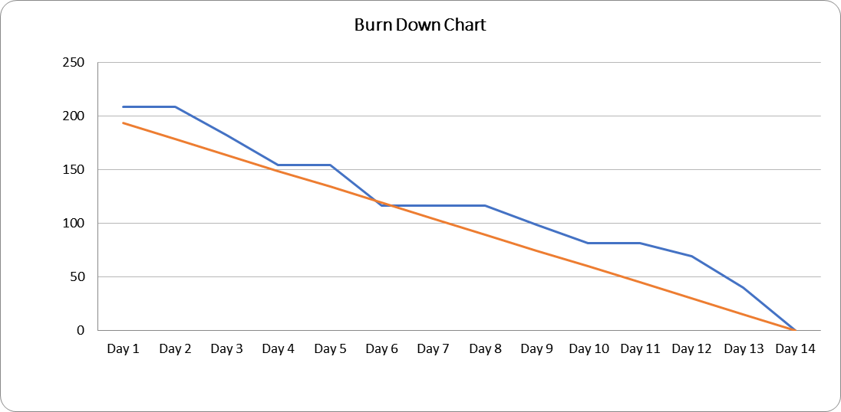

**Figure 1.** Sprint 1 Burn Down Chart

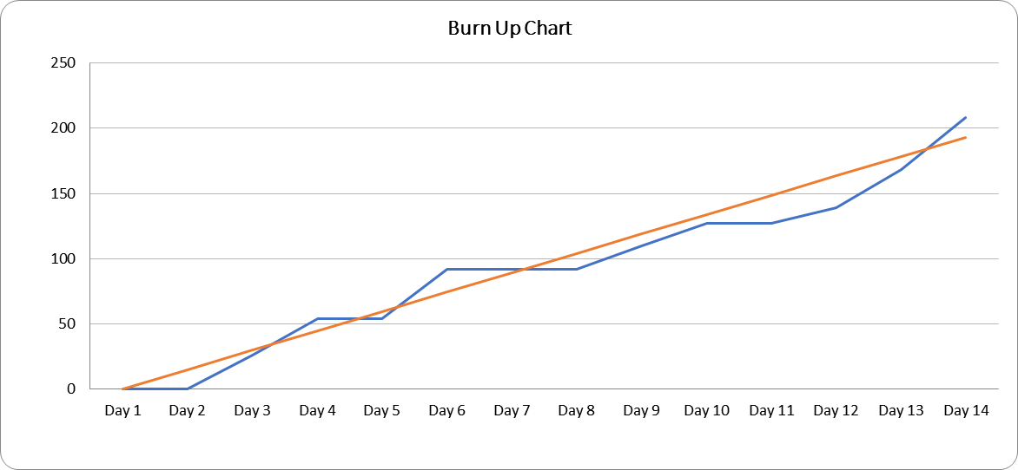

**Figure 2.** Sprint 1 Burn Up Chart

## Sprint 2

**Table 4.** Sprint 2

|  |  |  |  |  |  |  |  |  |  |  |  |  |  |  |  |  |  |  |  |  |  |  |  |
| --- | --- | --- | --- | --- | --- | --- | --- | --- | --- | --- | --- | --- | --- | --- | --- | --- | --- | --- | --- | --- | --- | --- | --- |
| Sprint Id | Backlog Id | Description | Owner | Status | Estimate (Hours) | Completed | Pending | Total effort | Effort vs. Estimate | Day 1 | Day 2 | Day 3 | Day 4 | Day 5 | Day 6 | Day 7 | Day 8 | Day 9 | Day 10 | Day 11 | Day 12 | Day 13 | Day 14 |
| 2.1 | PB04 | [FE] Design UX/UI Forget Password Page For Mobile Application | Ca | Done | 4 | 4 | 0 | 4 | 0 | 4 |  |  |  |  |  |  |  |  |  |  |  |  |  |
| 2.2 | PB04 | [FE] Code UX/UI Forget Password Page For Mobile Application | Ca | Done | 4 | 4 | 0 | 4 | 0 | 4 |  |  |  |  |  |  |  |  |  |  |  |  |  |
| 2.3 | PB04 | [FE] Code Forget Password Function For Mobile Application | Ca | Done | 3 | 3 | 0 | 3 | 0 |  | 3 |  |  |  |  |  |  |  |  |  |  |  |  |
| 2.4 | PB04 | [BE] Code Forget Password Function API | Phuc | Done | 4 | 4 | 0 | 3 | -1 | 4 |  |  |  |  |  |  |  |  |  |  |  |  |  |
| 2.5 | PB07 | [FE] Design UX/UI Change Password Page For Mobile Application | Ca | Done | 4 | 4 | 0 | 4 | 0 |  |  |  | 4 |  |  |  |  |  |  |  |  |  |  |
| 2.6 | PB07 | [FE] Code UX/UI Change Password Page For Mobile Application | Ca | Done | 4 | 4 | 0 | 4 | 0 |  |  |  |  |  | 4 |  |  |  |  |  |  |  |  |
| 2.7 | PB07 | [FE] Code Change Password Function For Mobile Application | Ca | Done | 8 | 8 | 0 | 4 | -4 |  | 8 |  |  |  |  |  |  |  |  |  |  |  |  |
| 2.8 | PB07 | [BE] Code Change Password Function API | Phuc | Done | 4 | 4 | 0 | 4 | 0 |  |  | 4 |  |  |  |  |  |  |  |  |  |  |  |
| 2.9 | PB01 | [FE] Design UX/UI Register Page For Web Application | Trung | Done | 8 | 8 | 0 | 8 | 0 | 8 |  |  |  |  |  |  |  |  |  |  |  |  |  |
| 2.10 | PB01 | [FE] Code UX/UI Register Page For Web Application | Trung | Done | 8 | 8 | 0 | 8 | 0 |  |  |  |  | 8 |  |  |  |  |  |  |  |  |  |
| 2.11 | PB01 | [FE] Code Register Function For Web Application | Trung | Done | 8 | 8 | 0 | 8 | 0 |  |  |  |  |  |  | 8 |  |  |  |  |  |  |  |
| 2.12 | PB03 | [DB + BE] Create Database (UR_USER, UR_ROLE, USER_ROLE, UR_SESSION) and Mapping entities | Phuc | Done | 8 | 8 | 0 | 8 | 0 |  |  |  |  |  | 8 |  |  |  |  |  |  |  |  |
| 2.13 | PB03 | [BE] Code Authorize Function (Personal User, Household, Local Authority, Admin) | Phuc | Done | 12 | 12 | 0 | 12 | 0 |  |  |  |  |  |  |  | 12 |  |  |  |  |  |  |
| 2.14 | PB01 | [FE] Design Web layout (household, local authority, admin) | Phuc | Done | 8 | 8 | 0 | 8 | 0 |  |  |  |  |  |  |  |  |  |  | 8 |  |  |  |
| 2.15 | PB02 | [FE] Design UX/UI Login Page For Web Application | Trung | Done | 2 | 2 | 0 | 3 | 1 |  |  |  |  |  |  | 2 |  |  |  |  |  |  |  |
| 2.16 | PB02 | [FE] Code UX/UI Login Page For Web Application | Trung | Done | 2 | 2 | 0 | 3 | 1 |  |  |  |  |  |  | 2 |  |  |  |  |  |  |  |
| 2.17 | PB02 | [FE] Code Login Function For Web Application | Trung | Done | 4 | 4 | 0 | 4 | 0 |  |  |  |  |  |  |  | 4 |  |  |  |  |  |  |
| 2.18 | PB02 | [FE] Code Logout Function For Web Application | Trung | Done | 2 | 2 | 0 | 2 | 0 |  |  |  |  |  |  |  |  |  | 2 |  |  |  |  |
| 2.19 | PB05 | [FE] Design UX/UI Edit Profile Page For Mobile Application | Ca | Done | 4 | 4 | 0 | 3 | -1 |  |  |  |  |  |  | 4 |  |  |  |  |  |  |  |
| 2.20 | PB05 | [FE] Code UX/UI Edit Profile Page For Mobile Application | Ca | Done | 4 | 4 | 0 | 5 | 1 |  |  |  |  |  |  | 4 |  |  |  |  |  |  |  |
| 2.21 | PB05 | [FE] Code Edit Profile Function For Mobile Application | Ca | Done | 3 | 3 | 0 | 4 | 1 |  |  |  |  |  |  |  | 3 |  |  |  |  |  |  |
| 2.22 | PB05 | [BE] Code Update Profile API | Phuc | Done | 3 | 3 | 0 | 3 | 0 |  |  |  |  |  |  |  |  |  |  |  |  | 3 |  |
| 2.23 | PB11 | [FE] Code Change Language For Mobile Application | Ca | Done | 12 | 12 | 0 | 15 | 3 |  |  |  |  |  |  |  |  |  |  |  |  |  | 12 |
| 2.24 | PB13 | [AI] Process Training Data | Huy | Done | 26 | 26 | 0 | 26 | 0 |  |  |  |  |  | 26 |  |  |  |  |  |  |  |  |
| 2.25 | PB13 | [AI] Train Model | Huy | Done | 26 | 26 | 0 | 26 | 0 |  |  |  |  |  |  |  |  |  |  |  |  | 26 |  |
| 2.26 | PB07 | [FE] Code & Design UX/UI Change Password For Web Application | Trung | Done | 4 | 4 | 0 | 4 | 0 |  |  |  |  |  |  |  |  |  |  | 3 |  |  |  |
| 2.27 | PB07 | [FE] Code & Design UX/UI Forget Password For Web Application | Trung | Done | 4 | 4 | 0 | 4 | 0 |  |  |  |  |  |  |  |  |  |  | 4 |  |  |  |
| 2.28 | PB06 | [FE] Code & Design UX/UI Add New Local Authority For Web Application(Admin page) | Trung | Done | 8 | 8 | 0 | 8 | 0 |  |  |  |  |  |  |  |  |  |  |  |  |  | 8 |
| 2.29 | PB02 | [BE] Code Login/Logout API | Phuc | Done | 12 | 12 | 0 | 15 | 3 |  |  |  |  |  |  |  |  |  |  |  |  |  | 15 |
| 2.30 | PB01 | [BE] Code Mail Service | Phuc | Done | 4 | 4 | 0 | 4 | 0 |  |  |  |  |  |  |  |  |  |  |  |  |  | 4 |
|  |  |  |  |  |  |  |  |  |  |  |  |  |  |  |  |  |  |  |  |  |  |  |  |
|  |  |  |  | **Total** | 207 | 207 | 0 | 211 | 4 | 20 | 11 | 4 | 4 | 8 | 38 | 20 | 19 | 0 | 2 | 15 | 0 | 29 | 35 |
|  |  |  |  | **Burn down** |  |  |  |  |  | 187 | 176 | 172 | 168 | 160 | 122 | 102 | 83 | 83 | 81 | 66 | 66 | 37 | 2 |
|  |  |  |  | **Burn up** |  |  |  |  |  | 20 | 31 | 35 | 39 | 47 | 85 | 105 | 124 | 124 | 126 | 141 | 141 | 170 | 205 |
|  |  |  |  | **Ideal Burn down** |  |  |  |  |  | 192 | 177 | 163 | 148 | 133 | 118 | 104 | 89 | 74 | 59 | 44 | 30 | 15 | 0 |
|  |  |  |  | **Ideal Burn up** |  |  |  |  |  | 0 | 15 | 30 | 44 | 59 | 74 | 89 | 104 | 118 | 133 | 148 | 163 | 177 | 192 |

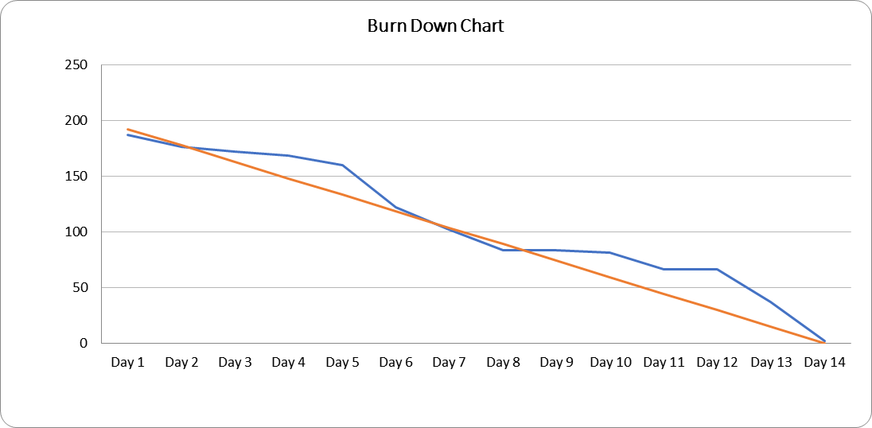

**Figure 3.** Sprint 2 Burn Down Chart

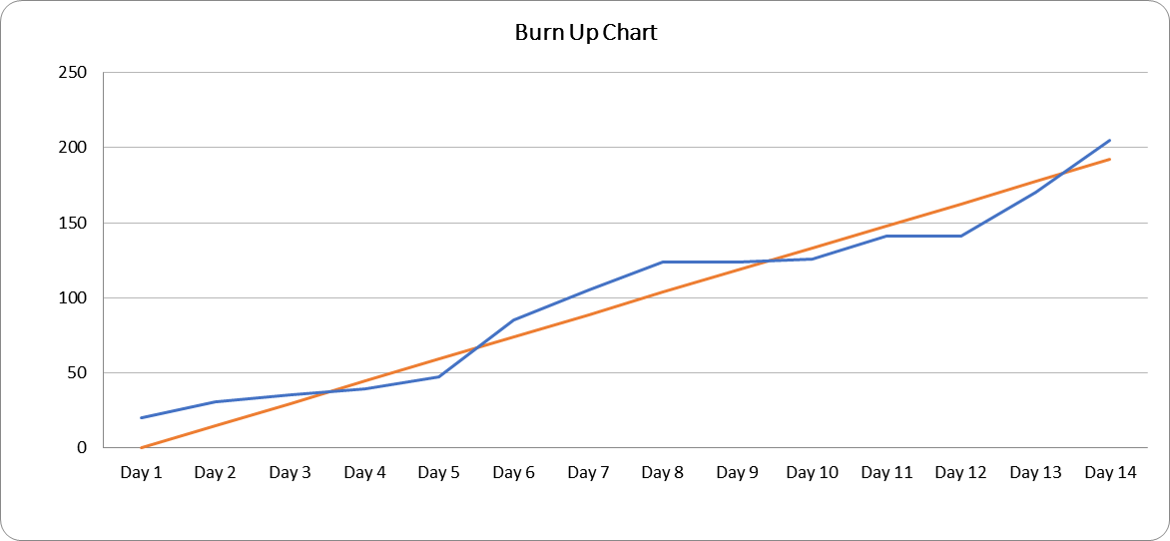

**Figure 4.** Sprint 2 Burn Up Chart

## Sprint 3

**Table 5.** Sprint 3

|  |  |  |  |  |  |  |  |  |  |  |  |  |  |  |  |  |  |  |  |  |  |  |  |
| --- | --- | --- | --- | --- | --- | --- | --- | --- | --- | --- | --- | --- | --- | --- | --- | --- | --- | --- | --- | --- | --- | --- | --- |
| Sprint Id | Backlog Id | Description | Owner | Status | Estimate (Hours) | Completed | Pending | Total effort | Effort vs. Estimate | Day 1 | Day 2 | Day 3 | Day 4 | Day 5 | Day 6 | Day 7 | Day 8 | Day 9 | Day 10 | Day 11 | Day 12 | Day 13 | Day 14 |
| 3.1 | PB08 | [FE] Design UX/UI Survey Page For Mobile Application (Personal User) | Ca | Done | 8 | 8 | 0 | 10 | 2 |  |  |  | 8 |  |  |  |  |  |  |  |  |  |  |
| 3.2 | PB08 | [FE] Code UX/UI Survey Page For Mobile Application (Personal User) | Ca | Done | 8 | 8 | 0 | 8 | 0 |  |  |  |  | 8 |  |  |  |  |  |  |  |  |  |
| 3.3 | PB08 | [FE] Code Take Photo Function | Ca | Done | 4 | 4 | 0 | 4 | 0 |  |  |  |  |  | 4 |  |  |  |  |  |  |  |  |
| 3.4 | PB08 | [FE] Code Location Base Function | Ca | Done | 8 | 8 | 0 | 7 | -1 |  |  |  |  |  |  |  | 8 |  |  |  |  |  |  |
| 3.5 | PB08 | [FE] Code Automatic Fill Data Function | Ca | Done | 8 | 8 | 0 | 12 | 4 |  |  |  |  |  |  |  |  |  |  | 8 |  |  |  |
| 3.6 | PB08 | [FE] Code Encrytion Image Function | Ca | Done | 8 | 8 | 0 | 5 | -3 |  |  |  |  |  |  |  |  |  |  |  | 8 |  |  |
| 3.7 | PB08 | [FE] Code Submit Survey Function | Ca | Done | 8 | 8 | 0 | 10 | 2 |  |  |  |  |  |  |  |  |  |  |  |  | 8 |  |
| 3.8 | PB08 | [BE] Code Location detection API | Phuc | Done | 10 | 10 | 0 | 8 | -2 |  |  |  |  | 10 |  |  |  |  |  |  |  |  |  |
| 3.9 | PB08 | [DB + BE] Create table User_Survey and Mapping entity | Phuc | Done | 12 | 12 | 0 | 10 | -2 |  |  |  |  |  |  |  |  | 12 |  |  |  |  |  |
| 3.10 | PB08 | [BE] Code Survey API | Phuc | Done | 18 | 18 | 0 | 18 | 0 |  |  |  |  |  |  |  |  |  |  |  | 18 |  |  |
| 3.11 | PB14 | [FE] Design UX/UI Declare Page For Web Application (Household) | Trung | Done | 8 | 8 | 0 | 9 | 1 |  |  | 8 |  |  |  |  |  |  |  |  |  |  |  |
| 3.12 | PB14 | [FE] Code UX/UI Declare Page For Web Application (Household) | Trung | Done | 8 | 8 | 0 | 8 | 0 |  |  |  | 8 |  |  |  |  |  |  |  |  |  |  |
| 3.13 | PB14 | [BE] Code Household API | Phuc | Done | 8 | 8 | 0 | 8 | 0 |  |  |  |  |  |  |  |  |  |  |  |  | 8 |  |
| 3.14 | PB15 | [FE] Design UX/UI Household Page | Trung | Done | 4 | 4 | 0 | 4 | 0 |  |  |  |  |  | 4 |  |  |  |  |  |  |  |  |
| 3.15 | PB15 | [FE] Code UX/UI Household Page | Trung | Done | 12 | 12 | 0 | 16 | 4 |  |  |  |  |  |  | 16 |  |  |  |  |  |  |  |
| 3.16 | PB06 | [BE] Code Admin API | Phuc | Done | 8 | 8 | 0 | 8 | 0 |  |  |  |  |  |  |  |  |  |  |  |  |  | 8 |
| 3.17 | PB13 | [AI] Test And Retrain AI Model | Huy | Done | 45 | 45 | 0 | 45 | 0 |  |  |  |  |  |  |  |  |  | 45 |  |  |  |  |
| 3.18 | PB13 | [AI] Write Pollution Detection API | Huy | Done | 8 | 8 | 0 | 8 | 0 |  |  |  |  |  |  |  |  |  |  |  | 8 |  |  |
| 3.19 | PB08 | [FE] Write Detection Pollution Function | Ca | Done | 8 | 8 | 0 | 12 | 4 |  |  |  |  |  |  |  |  |  |  |  |  |  | 8 |
|  |  |  |  |  |  |  |  |  |  |  |  |  |  |  |  |  |  |  |  |  |  |  |  |
|  |  |  |  | **Total** | 201 | 201 | 0 | 210 | 9 | 0 | 0 | 8 | 16 | 18 | 8 | 16 | 8 | 12 | 45 | 8 | 34 | 16 | 16 |
|  |  |  |  | **Burn down** |  |  |  |  |  | 201 | 201 | 193 | 177 | 159 | 151 | 135 | 127 | 115 | 70 | 62 | 28 | 12 | -4 |
|  |  |  |  | **Burn up** |  |  |  |  |  | 0 | 0 | 8 | 24 | 42 | 50 | 66 | 74 | 86 | 131 | 139 | 173 | 189 | 205 |
|  |  |  |  | **Ideal Burn down** |  |  |  |  |  | 187 | 172 | 158 | 144 | 129 | 115 | 101 | 86 | 72 | 57 | 43 | 29 | 14 | 0 |
|  |  |  |  | **Ideal Burn up** |  |  |  |  |  | 0 | 14 | 29 | 43 | 57 | 72 | 86 | 101 | 115 | 129 | 144 | 158 | 172 | 187 |

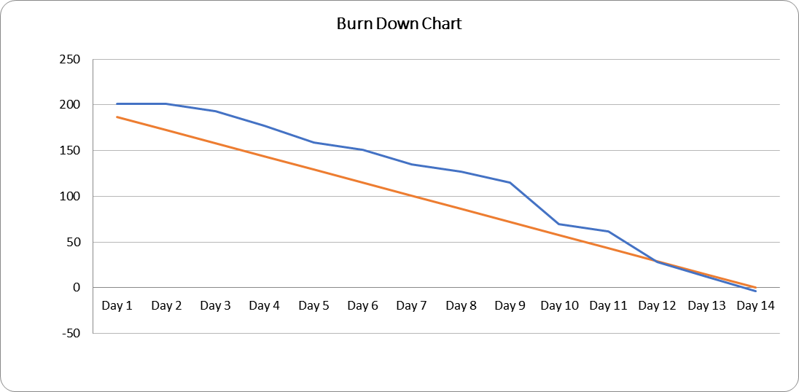

**Figure 5.** Sprint 3 Burn Down Chart

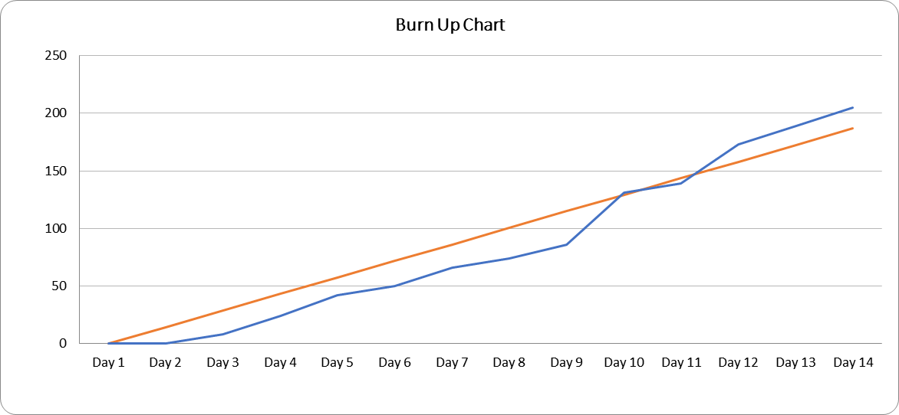

**Figure 6.** Sprint 3 Burn Up Chart

## Sprint 4

**Table 6.** Sprint 4

|  |  |  |  |  |  |  |  |  |  |  |  |  |  |  |  |  |  |  |  |  |  |  |  |
| --- | --- | --- | --- | --- | --- | --- | --- | --- | --- | --- | --- | --- | --- | --- | --- | --- | --- | --- | --- | --- | --- | --- | --- |
| Sprint Id | Backlog Id | Description | Owner | Status | Estimate (Hours) | Completed | Pending | Total effort | Effort vs. Estimate | Day 1 | Day 2 | Day 3 | Day 4 | Day 5 | Day 6 | Day 7 | Day 8 | Day 9 | Day 10 | Day 11 | Day 12 | Day 13 | Day 14 |
| 4.1 | PB12 | [FE] Redesign UX/UI View Finished Surveys Page For Mobile Application | Ca | Done | 8 | 8 | 0 | 10 | 2 | 8 |  |  |  |  |  |  |  |  |  |  |  |  |  |
| 4.2 | PB12 | [FE] Update UX/UI View Finished Surveys Page For Mobile Application | Ca | Done | 8 | 8 | 0 | 8 | 0 |  | 8 |  |  |  |  |  |  |  |  |  |  |  |  |
| 4.3 | PB12 | [FE] Update Function View Finished Surveys For Mobile Application | Ca | Done | 4 | 4 | 0 | 4 | 0 |  |  |  | 4 |  |  |  |  |  |  |  |  |  |  |
| 4.4 | PB12 | [BE] Update View Finished Surveys API | Phuc | Done | 12 | 12 | 0 | 10 | -2 |  | 12 |  |  |  |  |  |  |  |  |  |  |  |  |
| 4.5 | PB10 | [FE] Design UX/UI Accept/Decline New Village Page For Web Application | Trung | Done | 8 | 8 | 0 | 7 | -1 | 8 |  |  |  |  |  |  |  |  |  |  |  |  |  |
| 4.6 | PB10 | [FE] Code UX/UI Accept/Decline New Village Page For Web Application | Trung | Done | 8 | 8 | 0 | 8 | 0 |  | 8 |  |  |  |  |  |  |  |  |  |  |  |  |
| 4.7 | PB10 | [FE] Code Function Accept/Decline New Village For Web Application | Trung | Done | 8 | 8 | 0 | 9 | 1 |  |  |  |  |  | 8 |  |  |  |  |  |  |  |  |
| 4.8 | PB09 | [FE] Redesign UX/UI Survey Page With Add New Village For Mobile Application (Personal User) | Ca | Done | 4 | 4 | 0 | 5 | 1 |  |  |  |  |  |  |  | 4 |  |  |  |  |  |  |
| 4.9 | PB09 | [FE] Update UX/UI Survey Page With Add New Village For Mobile Application (Personal User) | Ca | Done | 8 | 8 | 0 | 8 | 0 |  |  |  |  |  |  |  |  | 8 |  |  |  |  |  |
| 4.10 | PB09 | [FE] Update Submit Survey With New Village Function | Ca | Done | 8 | 8 | 0 | 7 | -1 |  |  |  |  |  |  |  |  |  | 8 |  |  |  |  |
| 4.11 | PB14 | [BE] Code Dashboard API | Phuc | Done | 8 | 8 | 0 | 7 | -1 |  |  |  |  | 8 |  |  |  |  |  |  |  |  |  |
| 4.12 | PB13 | [AI] Research Multi-Label Classification Machine Learning | Huy | Done | 26 | 26 | 0 | 26 | 0 |  |  |  |  |  |  | 26 |  |  |  |  |  |  |  |
| 4.13 | PB13 | [AI] Crawl Training Data | Huy | Done | 26 | 26 | 0 | 26 | 0 |  |  |  |  |  |  |  |  |  |  |  |  |  | 26 |
| 4.14 | PB11 | [FE] Update Change Language For Mobile Application | Ca | Done | 8 | 8 | 0 | 8 | 0 |  |  |  |  |  |  |  |  |  |  |  | 8 |  |  |
| 4.15 | PB01 | [FE] ReDesign UX/UI Register Page For Mobile Application | Ca | Done | 4 | 4 | 0 | 4 | 0 |  |  |  |  |  |  |  |  |  |  |  |  | 4 |  |
| 4.16 | PB01 | [FE] Update Register Function Using Mail For Mobile Application | Ca | Done | 8 | 8 | 0 | 8 | 0 |  |  |  |  |  |  |  |  |  |  |  |  |  | 8 |
| 4.17 | PB14 | [FE] Design UX/UI Dashboard Page For Web Application | Trung | Done | 4 | 4 | 0 | 4 | 0 |  |  |  |  |  | 4 |  |  |  |  |  |  |  |  |
| 4.18 | PB14 | [FE] Code UX/UI Dashboard Page For Web Application | Trung | Done | 8 | 8 | 0 | 8 | 0 |  |  |  |  |  |  | 8 |  |  |  |  |  |  |  |
| 4.19 | PB01 | [BE] Update Register API Response Format | Phuc | Done | 12 | 12 | 0 | 10 | -2 |  |  |  |  |  |  |  |  | 12 |  |  |  |  |  |
| 4.20 | PB08 | [DB] Crawl Craft Village Data (VILLAGE) | Trung | Done | 25 | 25 | 0 | 25 | 0 |  |  |  |  |  |  |  |  |  |  |  |  |  | 25 |
|  |  |  |  |  |  |  |  |  |  |  |  |  |  |  |  |  |  |  |  |  |  |  |  |
|  |  |  |  | **Total** | 205 | 205 | 0 | 202 | -3 | 16 | 28 | 0 | 4 | 8 | 12 | 34 | 4 | 20 | 8 | 0 | 8 | 4 | 59 |
|  |  |  |  | **Burn down** |  |  |  |  |  | 189 | 161 | 161 | 157 | 149 | 137 | 103 | 99 | 79 | 71 | 71 | 63 | 59 | 0 |
|  |  |  |  | **Burn up** |  |  |  |  |  | 16 | 44 | 44 | 48 | 56 | 68 | 102 | 106 | 126 | 134 | 134 | 142 | 146 | 205 |
|  |  |  |  | **Ideal Burn down** |  |  |  |  |  | 190 | 176 | 161 | 146 | 132 | 117 | 103 | 88 | 73 | 59 | 44 | 29 | 15 | 0 |
|  |  |  |  | **Ideal Burn up** |  |  |  |  |  | 0 | 15 | 29 | 44 | 59 | 73 | 88 | 103 | 117 | 132 | 146 | 161 | 176 | 190 |

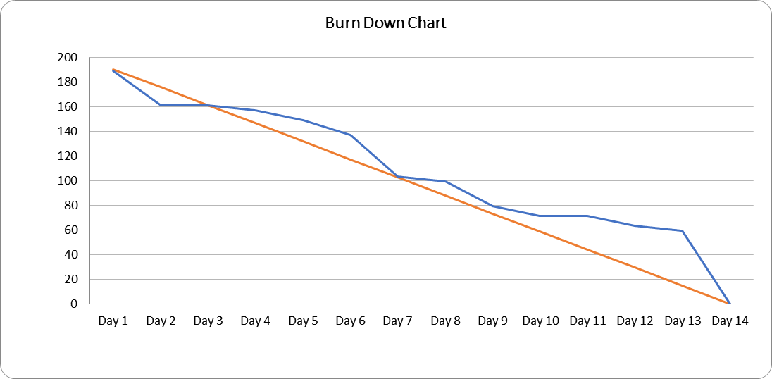

**Figure 7.** Sprint 4 Burn Down Chart

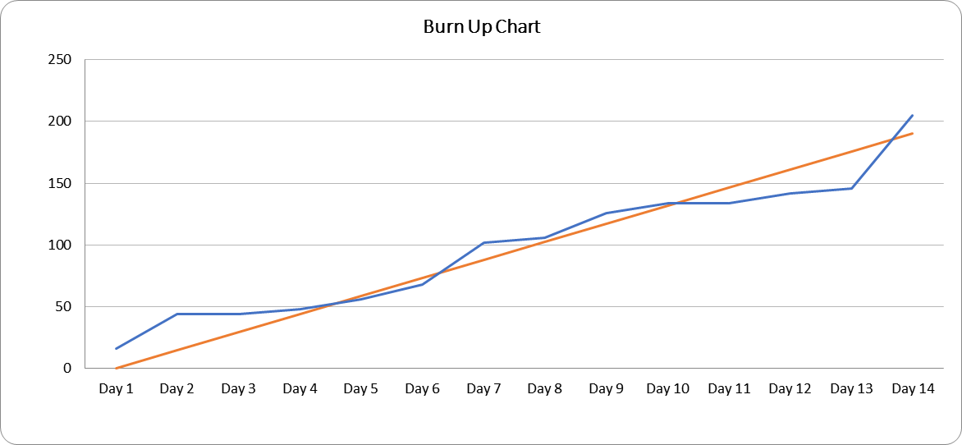

**Figure 8.** Sprint 4 Burn Up Chart

## Sprint 5

**Table 7.** Sprint 5

|  |  |  |  |  |  |  |  |  |  |  |  |  |  |  |  |  |  |  |  |  |  |  |  |
| --- | --- | --- | --- | --- | --- | --- | --- | --- | --- | --- | --- | --- | --- | --- | --- | --- | --- | --- | --- | --- | --- | --- | --- |
| Sprint Id | Backlog Id | Description | Owner | Status | Estimate (Hours) | Completed | Pending | Total effort | Effort vs. Estimate | Day 1 | Day 2 | Day 3 | Day 4 | Day 5 | Day 6 | Day 7 | Day 8 | Day 9 | Day 10 | Day 11 | Day 12 | Day 13 | Day 14 |
| 5.1 | PB13 | [AI] Process Training Data | Huy | Done | 20 | 20 | 0 | 20 | 0 |  |  |  |  |  | 20 |  |  |  |  |  |  |  |  |
| 5.2 | PB13 | [AI] Train New Model | Huy | Done | 20 | 20 | 0 | 20 | 0 |  |  |  |  |  |  |  |  |  | 20 |  |  |  |  |
| 5.3 | PB13 | [AI] Write Pollution Detection API | Huy | Done | 12 | 12 | 0 | 10 | -2 |  |  |  |  |  |  |  |  |  |  | 12 |  |  |  |
| 5.4 | PB08 | [FE] Write Detection Pollution Function | Ca | Done | 8 | 8 | 0 | 8 | 0 |  |  |  |  |  |  |  |  |  |  |  | 8 |  |  |
| 5.5 | PB08 | [FE] Code Submit Survey With New Village Function | Ca | Done | 8 | 8 | 0 | 8 | 0 |  |  |  |  |  |  |  |  |  |  |  |  |  | 8 |
| 5.6 | PB08 | [FE] Add Scroll Up Button For All Page | Phuc | Done | 8 | 8 | 0 | 8 | 0 |  |  |  | 8 |  |  |  |  |  |  |  |  |  |  |
| 5.7 | PB02 | [FE] Redesign UX/UI Home Page For Mobile Application | Ca | Done | 8 | 8 | 0 | 8 | 0 |  |  |  |  | 8 |  |  |  |  |  |  |  |  |  |
| 5.8 | PB02 | [FE] Update UX/UI Home Page For Mobile Application | Ca | Done | 12 | 12 | 0 | 8 | -4 |  |  |  |  |  | 12 |  |  |  |  |  |  |  |  |
| 5.9 | PB08 | [DB] Crawl Craft Village Data (VILLAGE) | Trung | Done | 40 | 40 | 0 | 40 | 0 |  |  |  |  |  |  |  |  |  |  |  |  |  | 40 |
| 5.10 | PB08 | [FE] Update Location Base Function | Ca | Done | 8 | 8 | 0 | 7 | -1 |  |  |  |  |  |  |  |  | 8 |  |  |  |  |  |
| 5.11 | PB08 | [BE] Update Location Base API | Phuc | Done | 8 | 8 | 0 | 8 | 0 |  |  |  |  |  |  |  | 8 |  |  |  |  |  |  |
| 5.12 | PB15 | [FE] Redesign UX/UI Household Page For Web Application | Trung | Done | 8 | 8 | 0 | 6 | -2 |  |  |  | 8 |  |  |  |  |  |  |  |  |  |  |
| 5.13 | PB15 | [FE] Update UX/UI Household Page For Web Application | Trung | Done | 8 | 8 | 0 | 8 | 0 |  |  |  |  | 8 |  |  |  |  |  |  |  |  |  |
| 5.14 | PB08 | [BE] Update Submit Survey API | Phuc | Done | 8 | 8 | 0 | 7 | -1 |  |  |  |  |  |  |  |  |  |  |  | 8 |  |  |
| 5.15 | PB09 | [FE] Redesign UX/UI Survey Page For Mobile Application (Personal User) | Ca | Done | 8 | 8 | 0 | 8 | 0 |  |  |  |  |  |  |  |  |  | 8 |  |  |  |  |
| 5.16 | PB09 | [FE] Update UX/UI Survey Page For Mobile Application (Personal User) | Ca | Done | 8 | 8 | 0 | 8 | 0 |  |  |  |  |  |  |  |  |  |  | 8 |  |  |  |
| 5.17 | PB11 | [FE] Update Change Language For Mobile Application | Ca | Done | 8 | 8 | 0 | 8 | 0 |  |  | 8 |  |  |  |  |  |  |  |  |  |  |  |
|  |  |  |  |  |  |  |  |  |  |  |  |  |  |  |  |  |  |  |  |  |  |  |  |
|  |  |  |  | **Total** | 200 | 200 | 0 | 190 | -10 | 0 | 0 | 8 | 16 | 16 | 32 | 0 | 8 | 8 | 28 | 20 | 16 | 0 | 48 |
|  |  |  |  | **Burn down** |  |  |  |  |  | 200 | 200 | 192 | 176 | 160 | 128 | 128 | 120 | 112 | 84 | 64 | 48 | 48 | 0 |
|  |  |  |  | **Burn up** |  |  |  |  |  | 0 | 0 | 8 | 24 | 40 | 72 | 72 | 80 | 88 | 116 | 136 | 152 | 152 | 200 |
|  |  |  |  | **Ideal Burn down** |  |  |  |  |  | 186 | 171 | 157 | 143 | 129 | 114 | 100 | 86 | 71 | 57 | 43 | 29 | 14 | 0 |
|  |  |  |  | **Ideal Burn up** |  |  |  |  |  | 0 | 14 | 29 | 43 | 57 | 71 | 86 | 100 | 114 | 129 | 143 | 157 | 171 | 186 |

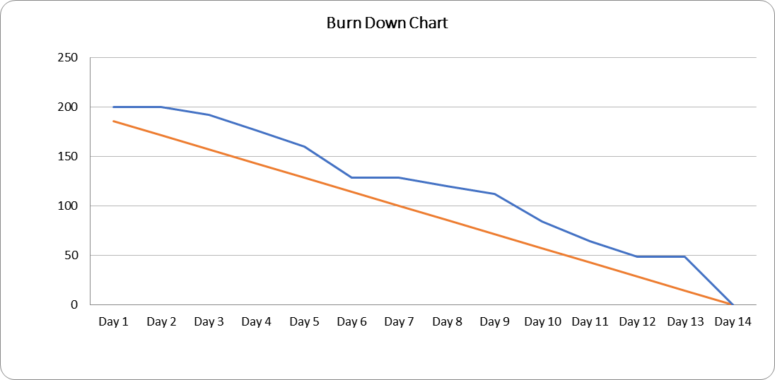

**Figure 9.** Sprint 5 Burn Down Chart

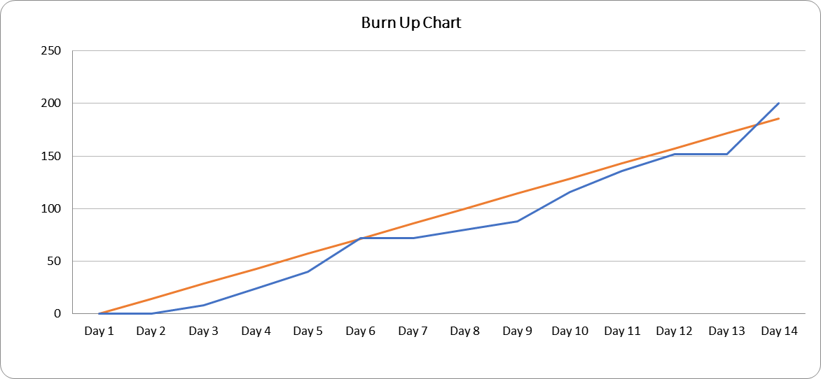

**Figure 10.** Sprint 5 Burn Up Chart

# Impediments

**Table 8.** Impediments

|  |  |  |  |  |  |  |  |
| --- | --- | --- | --- | --- | --- | --- | --- |
| **Id** | **Description** | **Raised By** | **Raised On** | **Owner** | **Status** | **Resolution** | **Resolved On** |
| 1 | I have a hardware problem when try to run the emulator for the project (Low on memory and storage) | Ca | 01/Sep/22 | Ca | Done | Buy hardware upgrade form the shop | 02/Sep/22 |
| 2 | My computer broke and I need two days for repair | Huy | 04/Sep/22 | Huy | Done | Bring the computer to the repair shop | 06/Sep/22 |
| 3 | I still haven't got the database software to work with | Trung | 03/Sep/22 | Phuc | Done | Use a remote software to help install the database software | 03/Sep/22 |
| 4 | I can't contact the group members immediately when I need to ask about problems in the project | Phuc | 09/Sep/22 | Ca | Done | Set up a meeting with the team and agree that we will have a daily meeting | 10/Sep/22 |
| 5 | I can't keep up with the daily meeting because I still have to go to school and the internship | Huy | 21/Sep/22 | Ca | Done | Set up a meeting with the team and agree that we will have a meeting every two or three days and the schedule will be set up in advance | 21/Sep/22 |
| 6 | I struggling to understand how to use the API and would like someone to help me out | Trung | 22/Sep/22 | Phuc | Done | The onwer will set up a meeting with the member for support | 22/Sep/22 |
| 7 | I don't have an Android phone to test the mobile application | Ca | 15/Oct/22 | Ca | Done | Buy an Android phone for the shop | 17/Oct/22 |

# Retrospective

**Table 9.** Retrospective

|  |  |  |  |  |  |  |
| --- | --- | --- | --- | --- | --- | --- |
| **Sprint #** | **Sprint #** | **Owner** | **Start Doing (Improvement)** | **Continue Doing (What Went Well)** | **Stop Doing (Even better if)** | **Remarks** |
| 1 | 2 | Huy |  |  | Let daily meeting become discussions. Keep them short. |  |
| 1 | 2 | Ca |  |  | Having conversations via email and not in the task. |  |
| 1 | 2 | Phuc |  | Attend meeting on time. |  |  |
| 2 | 3 | Huy | We completed the user stories we set out to do. |  |  |  |
| 2 | 3 | Ca |  |  | We didn't finish all the user stories. |  |
| 2 | 3 | Trung | We should start doing individual code reviews as we go. |  |  |  |
| 2 | 3 | Phuc |  | We should increase the amount we communicate as a team. |  |  |
| 3 | 4 | Ca | We were able to demo a working product to the mentor. |  |  |  |
| 3 | 4 | Phuc |  | We should continue having regular demos with the mentor. |  |  |
| 3 | 4 | Trung | Collect mentor feedback on new features. |  |  |  |
| 3 | 4 | Huy | Going through the entire Bug log. |  |  |  |
| 3 | 4 | Trung |  | We should continue working as a team. |  |  |
| 3 | 4 | Phuc | Review stories with mentor before implementation. |  |  |  |
| 4 | 5 | Trung |  | Great teamwork. |  |  |